Wilberforce Pendulum modelling PHYS1201 ASE project, 2022

By Campbell McTernan and Aditya Singh Tejas

**1.0 Abstract**

This report details the creation and simulation of a modified Wilberforce Pendulum to determine and analyse the accuracy of Euler-Lagrange approximations to a physically designed project. This investigation had modified the original design by allowing the pendulum to move in a traditional swinging motion, and also placing the system on a free support. The model was first tested with a naïve horizontal cylindrical weight1 which ultimately discarded due to erroneous wobbling2. The pendulum weight design was then altered3, which greatly reduced error. To model the pendulum, an experimentally validated model and trial-based best fit model were used. Overall, the trial model proved to be a more successful prediction of the pendulum’s motion. The average discrepancy between the best fit model and the video was _ cm 4 while the validated simulation had a discrepancy of _ cm 5. This shows that the constructed Wilberforce Pendulum was far more complex than point mass Lagrangian calculations can predict, showing that the use of rigid body components and complex friction is necessary to model this behaviour.

**2.0 Introduction**

**2.1 Aims and Hypothesis**

The overall aim of this experiment was to analyse the modified Wilberforce pendulum both by using theoretical modelling and experimental footage, but this can be more explicitly broken down into two separate aims:

1. To build a reliable and precise Wilberforce pendulum which could exhibit traditional characteristics, but also incorporated the key alterations
2. To simulate the modified system, and compare it with the physical model

It was expected that theoretical modelling would be visually similar to the physical footage, and furthermore that the simulation could predict the motion of the model to a few centimetres. Furthermore, the theoretical model’s accuracy was anticipated decrease exponentially with time, as pendulum systems with multiple articulated components often greatly in movement due to even the smallest variation in starting conditions. Lastly, measured constants were expected to be inferior to trial based estimations for the model, as they could account for unknown friction or uncertainty.q

**2.2 Physical Phenomena**

Pendulums of all designs are quite a common tool for the simulation of simple physics models as they provide a simple system which is reproducible and compact, while easily isolating individual physical phenomena for study. The characteristics of pendulums can also be measured quite accurately, evidenced by the fact that they are still used for precise experiments measuring physical constants.

A simple pendulum is usually constructed by hanging a heavy point mass like a ball from a rigid rod or string of negligible mass. As shown in Figure (1.1), due to the rigid rod the mass will always move in a circular arc from the fixed centre, and is constrained to the radius. If the mass is released at any distance from the equilibrium point, it will experience a force towards the equilibrium point, created by the difference between the tension on the spring and gravitational force / potential. This results in swinging motion wherein the velocity of the bob will be highest at the equilibrium point, and the velocity of the bob will be 0 at the outermost points. Furthermore, the gravitational potential will be the opposite: at its greatest at the outermost places, and lowest in the centre.

Figure (1.1) Simple pendulum

A traditional Wilberforce pendulum surprisingly acts in a completely separate fashion to regular gravitational pendulums. Instead, the pendulum is governed entirely by the properties of the string: if the mass is released from any point below or above its resting state, the spring force will act to give the mass vertical force. In turn, this force will result in acceleration, and eventually an overall stretch of some fashion in the spring. Subsequently, the coils of the spring must wind or unwind, which creates tortional potential energy in the spring, and causes the mass to rotate. As the spring winds and unwinds, this can then bob the mass upwards and downwards. Thus it is very simple to see that in a tradition Wilberforce Pendulum, the main forces acting on the system are Hooke’s law forces using the tortional and spring constants. In fact, gravity is not considered as an active factor in this motion. { A Wilberforce pendulum is constructed by hanging a mass vertically from a spring, where the mass is free to rotate in the direction of the coils. Wilberforce Pendulums are made interesting due to their prominent energy coupling qualities, as in traditional experiments energy is transferred between spring tortional potential and spring constant potential [and their kinetic components]. This allows calibrated pendulums to alternate between purely vertical and rotational motion in a dynamic lab demonstration. }

Figure (1.2) Traditional Wilberforce pendulum

In particular for science experiments, the Wilberforce pendulum as described by the physicist Lionel Robert Wilberforce in 18961 has proven quite popular due to its capability to alternate between purely vertical and rotational motion. Demonstrations of this apparatus and similar variations can be found from a variety of sources, such as from _source1_5 _source2_6 and _source3_7.

To extend on previous setup, and further test our understanding of physical phenomena we decided to alter the Wilberforce pendulum in two ways:

1. A free support of negligible mass was added to the top of the pendulum, and a frictionless rail was provided for it to slide across
2. The free support was designed to accommodate regular swinging motion like a simple pendulum

Figure (1.3) Modified Wilberforce Pendulum with specified named variables

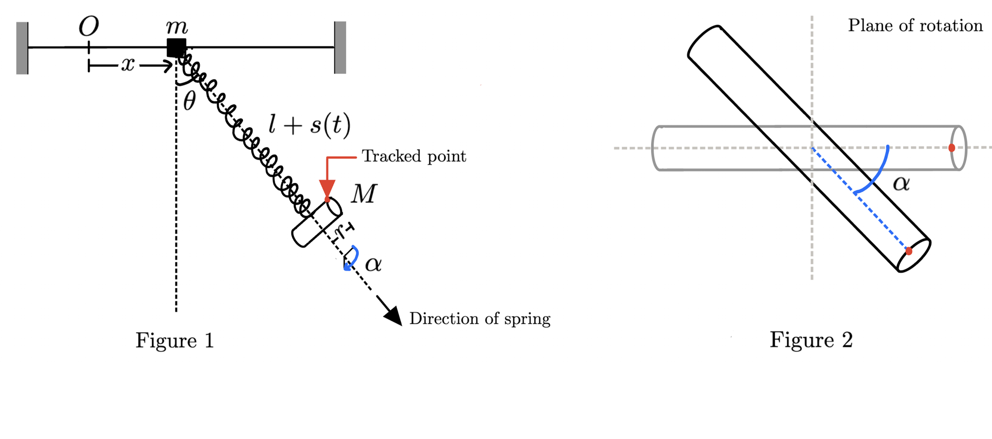

(maybe add what each variable means)

**2.3 Theory**

To model the Wilberforce pendulum, we will use Euler-Lagrange equations, which require calculation of the lagrangian:

Kinetic Energy

As the entire system is free to slide along a rail, the whole system can obtain a common velocity and thus kinetic energy. Defining $\dot{x}$  to be the velocity of the system in the $x$ direction, we have . Furthermore, the cylinder will have velocity relative to the system and rotational energy dependant on the rotational velocity given by and .

Hence, the total kinetic energy of the system is , so

Potential energy

We know that a spring with spring constant and stretch length has a spring potential . We also know that the torsional potential of the spring is . Since these potentials are coupled, we furthermore have the potential which represents the shared energy held during the transfer of energy between and in the system. As there are only two coupled components of potential, this relationship is linear and proportional to and . Thus, assume where is some constant. Finally, as this Wilberforce experiment has been made unique by the inclusion of traditional swinging pendulum motion, we also have gravitational potential .

Thus, the total kinetic energy of the system is , so

**3.0 System Design**

**3.1 Design Process**

Initially, the project was inspired by a presentation on Auto parametric resonance8 and a document on the Wilberforce Pendulum by Wolfram9. Figure (3.1) displays this initial model for a fixed support. Hence, the use of a cylindrical weight perpendicular to the spring was used, with nuts positioned on either side to manually adjust the moment of inertia of the mass. The initial project was then tested and filmed, shown in the results section, Figure (4.1) – (4.3).

?could talk about soldering, individual components etc?

As shown in the demonstration of the traditional Wilberforce setup, the system behaves as is intuitively expected, with motion similar to _source2_6 and _source3_7. However, when testing this system with the modified arc motion, the model seems to experience an unintended “wobble”, or oscillation around the point of connection for the spring as displayed in Figure (3.1). This oscillation persisted over a number of attempts and starting positions. As this experiment is intended to be founded entirely on physics and Lagrangian principles solely based on point mass approximations, we believe that this substitution of a point mass for a cylinder, despite the use of moment of inertia is to blame for this discrepancy. As the wobble involves motion and kinetic energy, we concluded that the wobble was coupled with the system, and was essentially storing energy in an unexpected and unwanted fashion.

Figure (3.1) Wolfram / Wikipedia initial inspiration

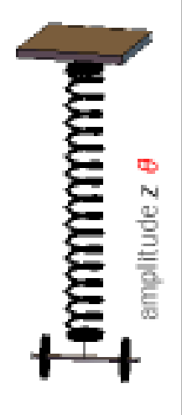

Ultimately, due to this unforeseen movement, we opted to entirely redesign the cylindrical mass, to be physically similar to _source2_6 and _source3_7, as shown in Figure (1.2). We believed that this solution would be more effective at minimising wobbling due to the distribution of mass. In Figure (3.1), the majority of the weight is skewed to each side. Thus, any slight wobbling from the apparatus causes high torque on the outer weights, and causes more movement and allocation of energy. In contrast, the design of Figure (1.2) centralises weight to provide a less substantial and stable wobbling motion. We conceded that this wobbling motion was erroneous but could not be stopped entirely. Later tests of this setup displayed far less wobble, and thus the design was accepted and used.

?could talk about gluing, base, clay, nails, components etc?

Mention frame, free support

**3.2 Method**

Figure (3.2): Frame and diagram apparatus of our setup in clean black lines

[]

As shown in Figure (3.2)

The mass is free to slide along a frictionless rail. The Wilberforce pendulum consists of a cylindrical mass (length and moment of inertia ) suspended at its mid-point by a helical spring of natural length , stretched length l + s(t), longitudinal spring constant and torsional spring constant . We assume that the spring has negligible mass and is rigid along its axis throughout the experiment. The cylinder must hang such that its axis is always in the plane orthogonal to the direction of the spring, and is able to rotate along this plane. The spring makes an angle from the vertical and the tracked point on the cylinder creates an angle measured from its starting point in the rotational plane: see Figure 2 . The horizontal position of the mass is noted as from the origin : see Figure 1. We choose the reference of the gravitational potential energy to be zero at the height of the origin. Note that the motion is actually in 3 dimensions but the direction into the page is essentially irrelevant to our defined equations of motion, as it can be represented by .

Note that there are four coordinates, that is, θ, , and . Thus there will be four Euler-Lagrange equations which must be solved simultaneously.

**4.0 Results**

**5.0 Discussion**

**6.0 References**

**7.0 Appendix**

a complex mechanical system as least as complex as a double pendulum. For this task, we have chosen the Wilberforce pendulum This is achieved through a coupling of the rotational and spring potential energy of the system. To extend this concept we have placed the system on a free support and allowed for a sideways swinging motion. To our knowledge, this setup has never been modelled before.

This project focuses on the description and analysis of the pendulum, using the Euler-Lagrange equations of motion to predict the pendulum's path and subsequently compare numerical simulations of the system with experimental data. This document primarily serves to describe the theoretical implications of design choices for the pendulum and to predict its path using computational software.

Introduction

This report details the creation and investigation of a Wilberforce Pendulum, which was first described by the physicist Lionel Robert Wilberforce in 1896. A Wilberforce pendulum is constructed by hanging a mass vertically from a spring, where the mass is free to rotate in the direction of the coils. Wilberforce Pendulums are made interesting due to their prominent energy coupling qualities, as in traditional experiments energy is transferred between spring tortional potential and spring constant potential [and their kinetic components]. This allows calibrated pendulums to alternate between purely vertical and rotational motion in a dynamic lab demonstration.

Wilberforce Pendulum Specification:

Introduction

* Physical Phenomena
* Theory
* Design Process

**3.0 Method**

**Results**

**Discussion**

**Conclusion**

**References**

<https://www.youtube.com/watch?v=S42lLTlnfZc>

<https://www.youtube.com/watch?v=AIBDgqATmFI>

<https://www.youtube.com/watch?v=9yVew0--jzw>

8 <https://www.youtube.com/watch?v=MUJmKl7QfDU>

9 <https://demonstrations.wolfram.com/TheWilberforcePendulum/>